


EVACUATION ALERT – RESCINDED Sept 16, 2025 at 1:00PM
Dusty Lake Fire Area (C51880)

Date: September 5, 2025 Time: 9:00 AM

This Evacuation Alert is jointly issued by Central Coast Regional District and Ulkatcho Nation, due to the Dusty Lake Wildfire Evacuation Orders for the communities of Ulkatcho Nation, Anahim Lake and Nimpo Lake.
Because of the potential threats to health, safety, and the welfare of persons, as well as potential restrictions for access and egress, due to adjacent Evacuation Orders (Dusty Lake Fire Area, Beef Trail Creek Area 2, and Charlotte Lake – Dusty Lake Fire Area) for residents and travelers, to Provincial Highway 20 this Evacuation Alert is issued for the following areas:

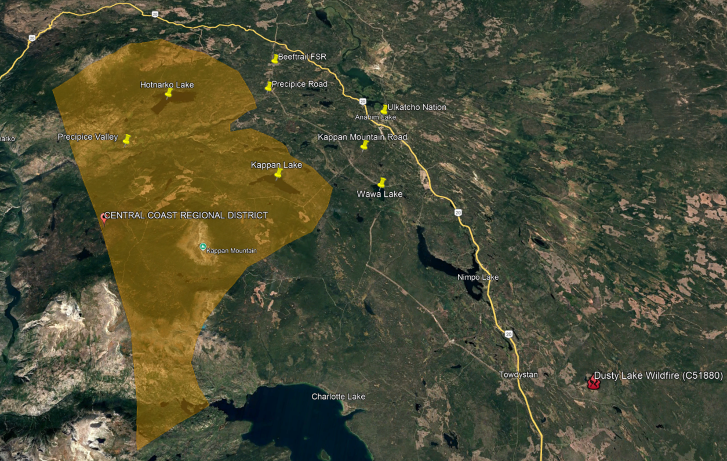

Disclaimer: The Central Coast Regional District does not warrant or guarantee the accuracy or completeness of the map.


Evacuation Alert Area
Geographic Location
Evacuation Alert Area
This evacuation alert is issued to prepare you to evacuate your premises or property should an evacuation order be made. Residents will be given as much advance notice as possible before evacuation is ordered; however, you may receive limited notice due to changing conditions.

WHAT YOU SHOULD DO:

- Locate all family members and designate a meeting area outside the evacuation alert area, should an evacuation order be made while family members are separated.
- Pack essential items such as government-issued ID, medications, important documents (e.g., insurance, and mortgage/tenancy information), and immediate care needs for dependents.
- Prepare to evacuate disabled persons, children, and/or neighbours if assistance is needed.
- Prepare to take pets with you and move livestock to a safe area (if possible).
- Arrange transportation for all your household members. Fill the gas tanks of personal vehicles that will be used in the evacuation. If transportation assistance is needed, call the CCRD at 250-982-0062.
- Review your home or tenant insurance policy to understand what coverage you may have for lodging and food in the event of being evacuated. Most basic insurance policies cover living expenses during an evacuation.
- Arrange accommodation for all members of the residence. If possible, plan to stay with family or friends as accommodations may be in short supply.
- If you will require government assistance to meet your basic needs if evacuated, like lodging and food, Emergency Support Services will be available. Create a profile at ess.gov.bc.ca.
- Wait for an evacuation order to be issued before evacuating. If you evacuate before being directed or authorized, you may not yet qualify for Emergency Support Services should you need it, as resources will be focused on those who have been ordered to evacuate.
- For the most up-to-date information on Alerts and wildfire information, please visit:
CCRD.ca
BC Wildfire Service
www.EmergencyInfoBC.ca

Jessie MacDonald
Emergency Program Coordinator,
Central Coast Regional District

Rod Cahoose
Emergency Management,
Ulkatcho Nation

For public inquiry, please contact:
Ulkatcho Nation: Rod Cahoose, 250-305-9113
Central Coast Regional District: 250-799-5291

